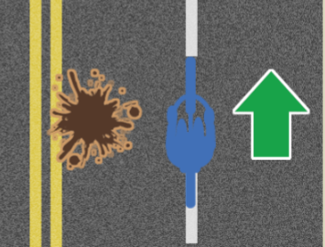

Hello !

We continued work on our 'Word Scramble' game today! After our setup up of functions, arrays and our while loop. He had to create the feature to be able to select a random word from our array, then we would jumble it up by selecting a random letter, adding that to a new array and then deleting that random letter from our original array. We do this by splicing the array!  
  
Splice is a new keyword when it comes to arrays. Splicing is how we DELETE something from an array. It looks like this “example.splice( 3 , 1 );” The first number is the index of where we want to start deleting, and the second number is how many things we want to delete. We use it here to randomly select a letter from our “normalWord”, push it into our “shuffledWord”, then delete it by splicing! This way our “shuffledWord” will be randomly filled up with letters from our “normalWord”, whilst the “normalWord” is deleted. The while loop makes us keep going until the “normalWord” is deleted! Overall, a while loop would be running so long as our original array still contained letters, so once everything had been deleted from our original array, our new array would be filled up with a jumbled up word! It's a very tough game to wrap your head around when coding but Christopher did brilliantly with it!